University Park Allocation Committee Requestor Handbook

Revised April 16, 2019

University Park Allocation Committee
Established 1996 – The Pennsylvania State University
208 HUB-Robeson Center – University Park, PA 16802 – (814) 863-8951

Table of Contents
- General Information ................................................................................................................................................. 1
  - Mission Statement .......................................................................................................................................... 1
  - Contact Information ...................................................................................................................................... 1
  - Meetings ............................................................................................................................................................. 1
    - General Allocation Review ................................................................................................................ 1
    - Standing Allocation Review .............................................................................................................. 1
    - Policy Review .......................................................................................................................................... 2
  - Minutes ................................................................................................................................................................ 3
  - Terminology ...................................................................................................................................................... 3
  - Important Points of Contact ....................................................................................................................... 5
- Funding Restrictions ................................................................................................................................................ 5
  - Repercussions of Violating Policy ............................................................................................................ 5
  - Maximum use of UPAC and SFB funds ................................................................................................... 5
  - Limitations on SIF fund use ....................................................................................................................... 6
  - Items that will not be funded .................................................................................................................... 7
  - Additional Funding Limitations ............................................................................................................... 8
  - Students Ineligible for Funding ................................................................................................................ 8
- General Allocation Requests ................................................................................................................................ 9
  - General Information ...................................................................................................................................... 9
    - Point of Contact ...................................................................................................................................... 9
    - Deadlines .................................................................................................................................................. 9
    - Miscellaneous Expenses ..................................................................................................................... 10
    - Fast Track Procedure .......................................................................................................................... 10
    - Addenda .................................................................................................................................................... 10
    - Tabling ....................................................................................................................................................... 10
  - Programs............................................................................................................................................................. 11
    - Guidelines ................................................................................................................................................. 11
    - The10% Rule ........................................................................................................................................... 11
    - Honoraria .................................................................................................................................................. 11
    - International Honoraria Recipients ............................................................................................... 12
    - Facility and Equipment Rental ......................................................................................................... 12
    - Clothing / Costumes / Apparel/Set Design/Props .................................................................. 13
    - Food Expenses ......................................................................................................................................... 13
    - Program Materials / Programs / Receptions / Awards / Prizes / Decorations ........ 13
    - Publicity ..................................................................................................................................................... 14
    - Ticket Sales ............................................................................................................................................... 14
    - Dates of Events ....................................................................................................................................... 14
  - Travel .................................................................................................................................................................... 15
    - Guidelines ................................................................................................................................................. 15
    - Travel Experience Categories ........................................................................................................... 16
    - Travel Procedures and Regulations ............................................................................................... 16
  - Equipment ........................................................................................................................................................... 19
  - Media ..................................................................................................................................................................... 20
  - Operational ......................................................................................................................................................... 20
    - Staffing Expenses ................................................................................................................................... 21
    - Telephone Expenses/Fax Machine Availability ........................................................................ 21
- Standing Allocation Requests ................................................................................................................................ 22
  - Current Standing Allocations ...................................................................................................................... 22
  - Attaining Standing Allocation Status........................................................................................................ 22
  - Losing Standing Allocation Status ............................................................................................................ 22
  - Budget Regulations.......................................................................................................................................... 23
  - Honoraria Caps for Organizations with Standing Allocation Status .......................................... 23
  - Collaboration ..................................................................................................................................................... 23
- Accessing funds allocated by UPAC .................................................................................................................... 24
  - Requestors with Associated Student Activities accounts ............................................................... 24
  - Requestors without ASA Accounts ........................................................................................................... 24
- Appealing Committee Decisions ........................................................................................................................... 25
  - Grounds of an Appeal ..................................................................................................................................... 25
  - Appeal Procedure ............................................................................................................................................ 25
  - Review of Grounds .......................................................................................................................................... 25
  - Review of Appeal ............................................................................................................................................. 25
  - Appealing Committee Decisions …………................................................................................................ 26
Appendix A – Service Trip Travel Window ............................................................................................................. 27
Appendix B – Allocation Decision Appeal Form and Appeal Outcome Review Form …………………. 28
Appendix C – Revision History ...................................................................................................................................... 32

1. General Information

1.1. Mission Statement
The mission of the University Park Allocation Committee (UPAC) is to objectively and effectively allocate a portion of the Student Initiated Fee (SIF) income towards events, travel experiences, equipment, and other items requested by University Park affiliated organizations or individuals that will ultimately enhance student life, add value to the out-of-class experience, and/or improve the educational climate at the University Park campus.

1.2. Contact Information
UPAC can be contacted via the following methods:
- Telephone: 814-863-8951
- Email: upac@psu.edu
- Mail Address: 208 HUB-Robeson Center, University Park, PA, 16802
- Web Address: www.upac.psu.edu

1.3. Meetings
Meetings of the full committee and sub-committees of the University Park Allocation Committee shall be conducted according to The Modern Rules of Order.
UPAC will conduct weekly meetings normally held each Tuesday and Thursday evening during the fall and spring semesters. All committee members are expected to be at assigned meetings in their entirety. Additional meetings may be scheduled, as circumstances warrant, by members of the Leadership Team.

1.3.1. General Allocation Review
This is the most common type of review that UPAC schedules. Each allocation team may meet as a sub-committee with a sub-committee Chair leading the meeting and an advisor providing guidance as needed.
Agendas are normally set for each allocation team and distributed to the committee members and scheduled requestors by the Thursday prior to the meeting in question. At least one (1) representative from the requesting organization is responsible for attending all scheduled allocation review meetings.
All decisions regarding general allocation requests are made during the sub-committee reviews, after a presentation by the requestor. Decisions are reached by a majority (50% + 1) vote of the committee members present, with the sub-chair voting in the event of a tie. Recommendations are voted on from most generous to least generous, as determined by the sub-chair.

1.3.2. Standing Allocation Review
Standing allocation reviews are scheduled during any part of the weekly meeting by UPAC on an as needed basis, normally during the spring semester. Exceptions may be granted at the Chair’s discretion. The full committee with the Chair leading the meeting and at least one (1) advisor providing guidance are required to perform a standing allocation review. All members of UPAC are expected to attend standing allocation reviews.
Agendas are set for standing allocation reviews and are distributed to the required attendees and committee members at least one (1) week prior to the meeting. At least one (1) representative from the requesting organization is responsible for attending all scheduled allocation review meetings to provide support of the information submitted by the organization.
Standing allocation reviews will begin with the Chair, committee members, advisors, requestor representative(s), and members of the public gallery taking their seats. The Chair will convene the review and introduce the requestor(s). A presentation from the requestor(s) will be provided, followed by a period of committee/requestor question and answer. The committee will then discuss the standing allocation request. Finally, the requestors and gallery will be asked to leave, allowing for a closed recommendation and voting session.
The Chair has the discretion to adapt the meeting process and schedule to best suit the committee’s and requestor’s needs.

1.3.3. Policy Review
Any student paying the Student Initiated Fee at University Park may research and generate policy recommendations for the UPAC Requestor Handbook.
The Leadership Team will review all policy proposals, correct factual errors in the background, and suggest additional changes. Any changes that the author declines will be written up as an addendum to the policy on a separate sheet by a Leadership Team member. The Leadership Team will assign a contact person for each policy change submission. If the policy is found to violate Student Fee Board policy, the author will be notified in writing. Suggested policy changes will be reviewed at the first available policy meeting. The author will be notified no less than twelve (12) academic days in advance of the meeting.
In order to change policy, UPAC must conduct a full committee meeting. In rare cases where it is not possible to convene the entire committee, it will be the responsibility of the Leadership Team to establish protocol. Quorum to convene a full committee meeting for the purpose of adopting policy is two-thirds (2/3) of the current general committee roster.
Changes to UPAC policies and procedures, approved by the full committee, will be effective at the beginning of the following academic year unless otherwise determined by the committee.
Policy reviews are scheduled during any part of the weekly meeting by UPAC on an as needed basis. The full committee with the Chair leading the meeting and at least one (1) advisor providing guidance as needed are required to perform a policy review. All members of UPAC are expected to attend policy reviews.
Agendas are normally set for policy reviews and are advertised via the UPAC website at least one (1) week prior to the meeting. The author of the policy recommendation is expected to attend the policy review.
Policy reviews will begin with the Chair, committee members, advisors, author(s), and members of the public gallery taking their seats. The Chair will convene the policy review and introduce the representative(s). A brief presentation and explanation from the representative(s) will be provided, followed by a period of UPAC/representative question and answer. The committee will then open the floor to brief comments from the gallery followed by a committee discussion of the policy proposal. Finally, the committee will issue final recommendations and then vote via anonymous balloting (e.g. iClicker or paper). If the person proposing the policy change is a member of the UPAC committee, they are permitted to vote on the policy change.
The committee may opt to vote in a different format: by a member making a motion, receiving a second to that motion, and achieving a majority vote (50% + 1) in favor.
The Chair has the discretion to adapt the meeting process and schedule to best suit the committee’s and proposing representative(s) needs.

1.4. Minutes
All meeting minutes are made available in the UPAC office and via the UPAC website, after notification of allocation is provided to the requestor. In the case of technology failure, you may request meeting minutes in an alternative format. To discuss the minutes, please contact the UPAC Staff Assistant to make an appointment with the Chair. If the Chair is not available, an Advisor may be able to assist you.

1.5. Terminology
UPAC defines the following terms as:
- Academic Day: any day University Park classes are in session. This does not include study days, final days, weekends, holidays and/or the days between semesters.
- Academic Year: the time period beginning the Monday after Summer Session II commencement through the Sunday of Summer Session II commencement the following year. The order of semesters in an academic year is: Fall, Spring, Maymester, Summer Session I, and Summer Session II.
- Addendum: request for an addition to an already approved UPAC budget request to cover unforeseen expenses not in the original budget.
- Bid: see “quote”.
- Community in need: includes, but is not limited to, an area of people negatively affected by a natural or man-made disaster, an area where the median household income falls within US poverty guidelines, or one where the high school drop-out rate exceeds the national average.
- Costume- A costume is defined as the clothes worn by a performer in an effort to appear to be a different person or thing. UPAC does not consider items that may be worn in casual, everyday scenarios to be a costume. (Examples include jean pants, solid-colored tee shirts, athletic wear, undergarments, leggings, etc.)
- Honoraria: payment for a professional service for which no traditional market price exists. Examples include, but shall not be limited to, speaker fees and performance/DJ fees (riders not included). Honoraria do not include non-performing DJ’s.
- GURU: General University Reference Utility – website referencing University policies
- Personal Networking: making contact and becoming acquainted with individuals or groups for individual or personal gain. Examples include, but shall not be limited to, career fairs, resume sessions, and job/internship interviews.
- Professional (in relation to field trips) – A person who has in the past, or currently is, working in an industry and has a professed expertise in a particular area.
- Program: any event (e.g., speaker, concert, conference, theater performance, cultural affair) that enhances the out-of-class experience provided by members of the Penn State community for students at Penn State – University Park.
- Quote: documentation specifying the details of item(s) or service(s) that is provided by the supplier that at a minimum includes, the price, quantity, and item/service description.
- Requestors:
  - Recognized Student Organizations: recognized through the Student Affairs – Office of Student Activities.
  - Non-recognized Student Organizations: groups of 6 or more students in a student organization that operates under a University affiliate, department, or is not officially recognized through the Student Affairs – Office of Student Activities.
  - Independent: any full-or part-time registered University Park student currently assessed the Student Initiated Fee.
  - Faculty/staff: University employees affiliated with a University Park department/unit.
- Organizations with Standing Allocation Status: a category of requesting organization that serves some type of campus-wide programming need that contributes to the well-rounded experience of all University Park students.
- Tabled: the decision to delay allocation of funds for a request or portions of a request as the result of, but not limited to, the request being incomplete, lacking pertinent information, or having discrepancies in calculations.
- Total Program Costs: the total expenses for execution of the program. Total program costs include, but are not limited to: the amount being requested from UPAC, expenses covered by any donations (community and in-kind), and expenses covered by student organization contributions. Total program costs do not include expenses incurred for items already owned by the student organization.
- Travel: any activity in which students leave the University to attend or participate in an experience not provided by Penn State students or faculty. All travel must accomplish an organizational function and/or improve a service offered to all students by bringing materials and information back to University Park.
- Travel Eligibility Fall-Spring: Students must be currently enrolled in University Park classes during the semester in which they are traveling. Students who have graduated and are no longer enrolled in classes are not eligible for funding.
- Travel Eligibility Summer: Students must be enrolled in University Park summer courses for the semester they will be traveling or registered for the upcoming fall semester at University Park. Students who have graduated and are no longer enrolled in classes are not eligible for funding.

1.6. Important Points of Contact
The following are points of contact that may be helpful as reference throughout the UPAC process.
- ASA (Associate Student Activities): this office serves as the financial (banking, accounting, paymaster) office for student organizations. All allocations to registered student organizations will be processed through this office. The office is located in 240 HUB-Robeson Center. They can be contacted via phone at: 814-865-1947. They can be contacted via email at: asa@sa.psu.edu.
- Events Management: this office handles reservation of and setup for spaces in the HUB-Robeson Center. Contact this office if utilizing space in the HUB-Robeson Center for a program or event. The office is located in 125 HUB-Robeson Center. They can be contacted via phone at: 814-865-7973. They can be contacted via email at: hubevents@psu.edu.
- OSA (Office of Student Activities): this office serves as the primary point of contact for all registered student organizations at University Park. This office monitors and assists student organizations with maintaining their status, training new officers, accessing student organization resources, and providing a variety of leadership and service programs. The office is located in 103 HUB-Robeson Center. They can be contacted via phone at: 814-863-4624. They can be contacted via email at: studentorg@sa.psu.edu.
- Program Registration: this office is the starting point for all registered student organizations that would like to have a program/event at University Park. They assist organizations through the process from start to finish with planning and executing an event. They provide the program registration form that is required to be signed by a program registration advisor prior to requesting UPAC funds. The office is located in: 125A HUB-Robeson Center. They can be contacted via phone at: 814-865-9273.
- Marketing: this office provides publicity, marketing, advertisement, and ticketing materials for student organizations. This office facilitates ticketing for UPAC-funded programs as well as marketing materials for events and programs at University Park. The office is located in 230 HUB-Robeson Center. They can be contacted via phone at: 814-865-5620. They can be contacted via email at: HUBmarketing@psu.edu.

2. Funding Restrictions

2.1. Repercussions of Violating Policy
UPAC reserves the right to audit any UPAC allocation. If the audit results in potential violations, the organization may be referred to the Office of Student Conduct. Any imposed penalties will be recorded internally and kept for three years.

2.2. Maximum Use of UPAC Funds
The total amount of funding from all UPAC funds cannot exceed ninety (90%) of total program costs. Organizations with Standing Allocation status, who receive SIF funds, can combine funds with UPAC allocated organizations in order to increase funding in any given category as long as total SIF funds do not exceed ninety (90%) of total program cost.

2.3. Limitations on SIF Fund Use
The information in this section is an excerpt from the SFB handbook. The official SFB handbook is the governing document and is available from student affairs at the following web page: studentfees.psu.edu
• Funding CANNOT be discriminatory, arbitrary, or capricious.
• Viewpoint neutrality must be followed when allocating any Student Fees. Based on court decisions, allocating boards must make decisions that are viewpoint neutral, which is defined as decisions that are not based on religious, political, or personal views. Furthermore, all viewpoints, including those that are controversial, must have an equal chance of receiving funding. However, it is not required that all groups be funded equally or that opposite views have to be funded. The same criteria used for other events, such as student interest and involvement, can be used to determine funding amounts for potentially controversial programs.
• No person or sponsoring organization may make a profit from a SFB-sponsored event.
• With approval from the sponsoring organization and the allocating body, a separate group may sell a commodity or raise funds at a SFB-sponsored event. One registered student organization may conduct approved fund-raising activities at SFB-supported events provided the main purpose of the activity being supported by the fee is not fund-raising and the event is free and open to the University community. A student who attends said event and does not donate must be able to gain the same experience from said event as someone who donates to the fund-raiser and attends said event. All proceeds from the fund-raiser must go toward a charity or philanthropy as defined by the IRS, and in the case of a US-based organization, has 501c3 tax exempt status or is a recognized student organization of The Pennsylvania State University. The registered student organization wishing to raise funds at an event supported by the Student Fee, but sponsored by another registered student organization, must have the permission of the sponsoring registered student organization to raise funds at the event. The sponsoring registered student organization of the event will have the final determination in the selection of the group to conduct the fund-raising activity. All fund-raising activities must be approved in advance by the Campus Allocation Committee and follow the procedures outlined in Policies and Rules for Student Organizations.
• Requestors must use SFB funds in the manner in which they were allocated.
• Activities sponsored by the SFB must be open to all University students at the campus that is funding the event. When funding events, campuses should consider the balance of accommodating fee-paying students and possibly accommodating guests. In determining whether to make an event open to guests, campuses will be mindful of risk management issues, being welcoming to adult learners and their family members, and other students with varying needs.
• Student Fees shall not be used to backfill expenses from the general funds budget, nor should the Student Fee be used to replace what is currently funded through the general funds.
• Any organization receiving funds directly from the SFB may not request additional funds from a Campus Allocation Committee.
• Individual chapters recognized by IFC, NPHC, MGC, and Panhellenic Council are eligible for funding only when the event is open to the entire University population.
• Money may be used for wages (preferably for students) and, in the case of services, salaries. In some cases, wages for professional staff may be appropriate when student employees with appropriate time and/or experience are not available. Approval for use of activity fee money for specific salaries must be given by the Student Fee Board and must be endorsed by both the Vice President for Student Affairs and the President.
• Co-sponsorships: UPUA, GPSA, and CCSG have the option of using portions of their budget to co-sponsor. Co-sponsorship, as pertaining to fixed allocation funds, is the ability to host an event or initiative in conjunction with another student organization, entity, or off-campus establishment (i.e., the Borough Council).
a. UPUA, GPSA, or CCSG must take part in the planning of any event for which they are a co-sponsor. Organizations must go before these student governments and ask them to cover specific expenses of their program.
b. Co-sponsorship does not apply to events jointly funded by UPUA, GPSA, and CCSG.

2.4. Items that will not be Funded
The information in this section is an excerpt from the SFB handbook. The official SFB handbook is the governing document and is available from student affairs at the following web page: studentfees.psu.edu.
7.2. ITEMS THAT WILL NOT BE FUNDED
1. Appropriations in furtherance of a political campaign or activity by any candidate or candidate’s staff for political office.
2. Appropriations to a legislative lobby or to a registered student organization whose primary purpose is to influence legislation.
3. Grants-in-Aid and scholarships.
4. Salaries and stipends may only be funded by the SFB.
5. Donations or charitable contributions of money or products.
6. Funding of philanthropic activities where the primary purpose is fund-raising.
7. Retroactive expenses (events held prior to submitting the request for funding or events where funding has been committed before being notified of approval).
8. National association memberships on a per person basis. Individual memberships are not permitted; however, group memberships to a national organization are allowed.
9. Membership dues for fraternities or sororities.
10. Programs and activities that are for academic credit and/or are considered an essential component of a class (not attending or participating could have a negative effect on a student’s grade in the course).
11. Hiring of legal services or providing bail-bond funds.
a. This does not include funding for a Student Legal Services office, which is available to all fee-paying students at University Park.
12. Honoraria for Penn State faculty or staff speaking about his/her area of expertise
13. Purchase of a specific gift for a specific person or items used to raise funds. This means that promotional items for events, door prizes, and participation prizes that are distributed randomly are allowable expenses to purchase with the Student Fee.
14. Personal, non-contractual gain of any student, faculty member, staff member, or any other person.
15. Purchase of or reimbursement for the purchase of alcoholic beverages.
16. Any religious ceremony or worship service, except when such activity is for educational purposes.
17. Any activity, material, or program whose primary purpose is recruitment or increased membership in the sponsoring group.
All expenditures must be in compliance with University Policies and Rules and Policies and Rules for Student Organizations.
The Pennsylvania State University prohibits discrimination and harassment against any person because of age, ancestry, color, disability or handicap, national origin, race, religious creed, sex, sexual orientation, gender identity, or veteran status. Discrimination or harassment against faculty, staff, or students will not be tolerated at The Pennsylvania State University.

2.5. Additional Funding Limitations
The following items will not be considered for funding by UPAC:
- All medications including off-the-shelf and over-the-counter medications with or without a prescription.
- Expenses for advisor, staff, and faculty travel.
- Health insurance, travel insurance, or health provider expenses.
- Group memberships to a national organization.
- UPAC will not consider funding any performers, speakers, or any other person that is requesting compensation for a product or service they provide if said person is also a member of the organization requesting funding.
- Videographers, photographers, live streaming, and/or any other related costs, to the affirmed are not eligible for UPAC funding unless adequate proof that these resources are integral to the success of the event, and whose primary purpose is to enhance the University Park student’s experience gained from the event. Per University policy, faculty and staff may not receive payment for these types of services if it falls within their scope/area of expertise.

2.6. Students Ineligible for Funding
Requestors who are not assessed the University Park Student Initiated Fee during the semester of their experience or the following fall are not eligible for UPAC funding.

3. General Allocation Requests
General allocation requests consist of the following types of requests: Program, Travel, Equipment, Print Media, Broadcast Media, and Operational expense.

3.1. General Information
All required items within a request form must be complete (all line items applicable to the request form are filled out with all supporting documents attached). The budget will be considered accepted once a UPAC affiliate signs in the budget request form. UPAC will follow a first come, first served procedure when scheduling requests for review. Requests will be considered in the order received by UPAC as the first order of priority. Additionally, requests will be considered in the order approved for review by the Chair as the second order of priority. Incomplete requests will not be scheduled until the Chair has determined that all required items have been submitted to UPAC.
All required documentation submitted with the request must be in the form of US dollars and may not be converted from other currencies by the requestor. All quotes must come from service providers.
Do not commit yourself financially until written notification of UPAC funding. No retroactive events or expenses will be considered for funds or reimbursement. This includes the purchasing of transportation including, but not limited to, airfare tickets, bus tickets, etc.
All allocated funds must be expensed in the academic year in which they were allocated. Any requests for reimbursement must be submitted no later than May 31st in order to be processed prior to the close of the fiscal year.

3.1.1. Point of Contact
When a requestor signs out a form to request program, equipment, media, or travel funding from the UPAC office, a UPAC member from the Student Contact Team (SCT) is assigned to work with the requestor. The SCT member provides a point of contact and assistance with any concerns or questions about the general allocation request. It is imperative that the requestor and SCT member meet to discuss the request. The SCT member will represent the requestor and advocate on their behalf to one of the allocation teams. The requesting individual or group representative is encouraged to be present at the meeting to answer questions. The SCT member is expected to contact the requestor within three (3) academic days of signing out a request. It is also the responsibility of the requestor to be in touch with the SCT member. In the event that your organization has not been contacted, please contact the UPAC office.

3.1.2. Deadlines
All requests must be complete to be accepted for review. After deadlines have lapsed, incomplete budgets may be turned down at the discretion of the Chair, and that request may not be resubmitted for funding. Requestors must meet with their assigned UPAC SCT member to assure completion prior to deadlines. A deadline of forty (40) academic days prior to the experience date applies to all program and travel requests. A deadline of the last academic day of the fall semester applies to all other requests.

3.1.3. Miscellaneous Expenses
UPAC does not fund miscellaneous expenses (e.g., emergency expenditures, unforeseen expenses, last minute details, etc.). All expenditures being requested must be line-itemed and supported with proper documentation.

3.1.4. Fast Track Procedure
The UPAC Chair reserves the right to review budget requests as a “fast track” review, should the budget meet the following criteria:
- The requestor has submitted a request to UPAC in the previous or current academic year.
- The allocation does not exceed $15,000.
- The Chair allocates full funding based on UPAC policy.
- The UPAC advisor approves the Chair’s allocation.
- The approved allocation is presented to the UPAC Leadership Team.
Any budget that does not meet the above criteria will be scheduled for a full review with an allocation team.

3.1.5. Addenda
When additional or unforeseen expenses arise, a requestor may submit an addendum. Requestors must submit a letter to UPAC that explains the costs and the rationale for the additional request. UPAC will only consider additional allocations for expenses that are necessary for the success of the program/travel, have increased since the allocation was made, and were not originally submitted/included/considered during UPAC’s previous reviews of the budget.
Addenda for equipment allocations will only be considered for price changes, quantity changes, vendor changes, and similar item substitutions. Requests for additional items will not be considered.
UPAC requires that notification of any changes to the event be submitted in writing at least ten (10) academic days before the start date of the event. Failure to do so may affect the funding of the event. It is strongly encouraged that requests are submitted as early as possible.
Organizations with Standing Allocation status are not allowed to submit addendum requests.

3.1.6. Tabling
An entire request or portions of a request may be tabled for a number of reasons including, but not limited to, the request being incomplete, lack of pertinent information, and discrepancies in calculations.
When items are tabled, they are set aside. No money has been allocated toward these tabled expenses. Once the issue for tabling has been remedied, proper documentation must be submitted to the UPAC office at least ten (10) academic days prior to the event. At this time, another hearing will be scheduled for the tabled items to be removed from the table and will be reviewed by the committee. When items are brought back from the table, the items may be reviewed without the need of the requestor to be present unless the requestor would like to attend or the sub-committee requests their presence. If updated information for the tabled item(s) has not been submitted within the ten (10) academic day deadline, the tabled items may be removed and considered ineligible for UPAC funding.

3.2. Programs
Prior to signing out a UPAC program funding request form, requestors must start with the program registration form available in 125 HUB–Robeson Center or online at http://reservations.psu.edu. Once this form is completed and signed by a program advisor, a program funding request form may be signed out from UPAC.
Program request forms must include appropriate materials including a quote for the honoraria, honoraria biography and reviews, venue confirmation, banner space confirmation, and bids for all items to be purchased or rented. A total budget must be submitted with your program request including documentation and bids for non-requested or non-fundable items for the program.

3.2.1. Guidelines
UPAC defines a program as any event (e.g., speaker, concert, conference, theater performance, cultural affair) that enhances the out-of-class experience provided by members of the Penn State community for students at Penn State – University Park.
UPAC will not consider funding for events that are not open to the entire University Park student body.
The Student Fee Board and UPAC limit funding of events sponsored by the Interfraternity Council (IFC), Panhellenic Council (PHC), National Pan-Hellenic Council (NPHC), or Multicultural Greek Council (MGC) to those that are open to the entire student body and are held in locations other than fraternity houses or sorority suites.

3.2.2. The 10% Rule
Requestors are responsible for a MINIMUM of ten percent (10%) of their total program cost.

3.2.3. Honoraria
No student group may be funded for more than $20,000 in honoraria during an academic year. An organization may be funded a maximum of one (1) honorarium for $20,000.00 or any number of honoraria at a combined price of $20,000.00. Regardless of group collaboration, no one honoraria recipient may receive more than $20,000.00 in Student Fees per event. Discount towards honorarium will not be considered towards total program cost.
One (1) day events are eligible for any number of honoraria recipients not to exceed $20,000.00 regardless of the number of cosponsoring requestors.
UPAC discourages funding for honoraria recipients who have performed at University Park campus within the last twelve (12) months.
All recognized student organization general allocation requestors may request to utilize up to $500.00 of their yearly honoraria allotment to cover hospitality riders as stated in the contract for honoraria recipients. If this item is an addendum to a previous request, it must go through the Fast Track review process. Additionally, no support staff is eligible for UPAC funding.
Lodging and travel expenses are considered for honoraria recipients only, including recipients who do not request an appearance or performance fee. Lodging and travel exceptions may be considered based on technical and mechanical personnel required for staging. Lodging expenses for honoraria recipients are capped at $100/room per night.
When requesting funds for honoraria, the detailed program schedule should include the expected performance time for each honoraria recipient.
UPAC will not consider a Recognized Student Organization as a recipient of an honoraria.
Per Diem expenses for honoraria recipients will not be considered for funding unless stated in the contract.

3.2.4. International Honoraria Recipients
If honoraria recipients are eligible to receive payment or reimbursement for expenses under United States law, then UPAC will consider funding the honoraria.
Requestors bringing in international honoraria recipients may work with a University Department willing to verify valid visa and passport information and willing to cover the expenses of the honoraria recipient and then subsequently be reimbursed from the sponsoring organization with UPAC funding. A letter from the department stating that they have verified required visa and passport documentation and agree to the above must be attached when submitting the request.
A University Department may incur expenses for which they expect to be reimbursed only after a requestor has been notified of funding by UPAC. The University Department must submit, on letterhead, a list of incurred expenses plus a copy of the respective receipts to the sponsoring student organization in care of the Associated Student Activities Office (ASA) located in 240 HUB-Robeson Center. The department will be reimbursed by the sponsoring student organization. For independent requestors and non-recognized student organizations, the department may submit the request for reimbursement directly to the UPAC staff assistant.
In addition, a requestor may work directly with their assigned contract advisor to determine whether the honoraria recipient is eligible to receive a 1099 payment in the U.S. and determine the appropriate documents necessary to make the payment. All documentation must be received and approved by the contract advisor before the requestor may finalize the arrangements with the recipient.
In some cases, international honoraria recipients may be required to pay a 30% income tax. The requestor may include that additional amount as part of their honoraria request and it will count towards the yearly $20,000.00 honoraria cap. Addendums to fund the 30% after the allocation for honoraria is made will not be considered and will be the sole responsibility of either the requestor or the recipient.
Any contracts brought in for final signature after the event, in certain circumstances, may not be funded.
UPAC does not allocate funds towards travel outside of the 50 United States or the District of Columbia. UPAC will consider transportation for international honoraria recipients once they are within the 50 United States or the District of Columbia.

3.2.5. Facility and Equipment Rental
A confirmation of venue reservation must be attached to the request.
If requiring equipment and/or services through the Office of Physical Plant (OPP), a requestor must work directly with the Events Management Office in 125 HUB-Robeson Center to secure quote(s). This would include such things as: electrical needs, stages, risers, tables, chairs, etc.
If renting equipment from an outside vendor, a copy of the written quote is required to be submitted with your request.

3.2.6. Clothing/ Costumes/ Apparel/ Set Design/ Props
UPAC may consider requests for costumes only (purchase, rental, and cleaning). UPAC caps costume requests at $1,500 per academic year.
Casual wear such as jeans, solid tee shirts, leggings, undergarments, shoes, and athletic wear will not be considered for funding under this policy. An inventory of an organization’s current costume and clothing holdings must be submitted with any new clothing request submission.
Organizations must also include a discussion of why the currently held items are not sufficient to complete the organization’s mission. Set design and prop purchases and rental will be considered, but an organization must show how the items enhance the program experience, why the items are necessary for the successful completion of a program, and why alternative methods for acquiring these items are not feasible.
An up-to-date inventory list of costumes and props must be submitted to UPAC along with any budgets requesting funding for costumes or props. UPAC will not consider new requests until an inventory list has been received in the UPAC office.

3.2.7. Food Expenses
UPAC will not fund food or food-related expenses for programs. If UPAC allocates funds for the program of which food is a part and there is a charge for the food, then the food portion must be an optional part of the program and students should not be charged or should have a lower ticket price to attend.

3.2.8. Program Materials/ Programs/ Receptions/ Awards/ Prizes/ Decorations

3.2.8.1. Programs/ Pamphlets/ Event Guides
UPAC will consider items that meet all of the following criteria:
- are used for educational purposes,
- include some information essential to program participation, AND
- are integral to the success of the program.

3.2.8.2. Decorations
UPAC will consider items that meet all of the following criteria:
- are integral to the success of the program.

3.2.8.3. Receptions/ Awards/ Prizes
UPAC will consider items that meet all of the following criteria:
- are used for educational purposes,
- include some information essential to program participation, AND
- are integral to the success of the program.
UPAC does not fund gifts that can be considered awards. This can include, but is not limited to: awards, honors, trophies, bouquets, donations, scholarships, or stipends.
The following has been established by the Student Fee Board:
“The fee CANNOT be used to purchase a specific gift for a specific person or items used to fundraise. This means that promotional items for events, door prizes and participation prizes that are distributed randomly are allowable expenses to use the Student Initiated Fee.”
UPAC will not consider funding for promotional items, door prizes, or participation prizes (e.g. water bottles, mugs, pens, shirts).

3.2.9. Publicity
All advertising related to events funded by UPAC must prominently display the phrase "Funded by the Student Initiated Fee.”
UPAC will not consider funding advertising in any print media, including, but not limited to, The Daily Collegian (Collegian Inches) or Centre Daily Times.
All UPAC-funded events are eligible for one large poster or two medium posters through the HUB Marketing Office (230 HUB-Robeson Center). Banners and additional posters may also be purchased. For more detailed information you may contact the HUB Marketing Office.
UPAC will not consider funding for promotional items, door prizes, or participation prizes (e.g. water bottles, mugs, pens, shirts).

3.2.10. Ticket Sales
For all events requiring a fee/ticket for admission, all University Park student fees/tickets must be less expensive than that of all other attendees (including children). University Park students must be given first priority for ticketed events/activities.
Once tickets have been printed, you will be notified that the tickets and a ticket accountability form will be available for pickup in the ASA Office. The ASA Office staff will explain the accountability procedures for the distribution of tickets and the deposit of tickets sales funds.
Within forty (40) academic days of the completion of a ticketed, UPAC-funded event, the requestor must submit a reconciliation of all revenues and costs associated with the event to the UPAC office. The reconciliation must include documentation of revenues from the box office (if group uses a University-supported box office or an off-campus box office). It must also include documentation from ASA indicating the costs of the event. If reconciliation is not submitted within forty (40) days and any excess revenues up to the amount allocated are not returned to UPAC, UPAC reserves the right to limit future requests until the account is reconciled. A hold will also be placed on their restricted ASA account until the reconciliation is submitted and the funds returned.

3.2.11. Dates of Events
UPAC considers funding of programs which occur during times when students are required by the University to be at University Park. UPAC may consider funding for programs that occur before classes begin for a semester or session, with those allocations deducted from the following semester’s fund.
In accordance with the University Policies and Rules for Student Organizations, “no recognized student organization may schedule or sponsor any events on or off campus beginning at 8 a. m. Saturday after the last day of classes through 8 a. m. the Monday following final exams. This does not include participation in events scheduled by conference, regional, or national affiliates. ”For more information regarding this policy please refer to: http://studentaffairs.psu.edu/organizationrules/.

3.3. Travel
All requests must be complete to be accepted for review. Travel requests must include a published description and itinerary of the conference (or comparable description and itinerary from a previous year), complete breakdown of costs, a roster of students, as well as all required travel- related quotes.

3.3.1. Guidelines
UPAC will consider funding Educational, Competitive, Performance, and Service experiences as defined further in this handbook. Certain restrictions may be placed on items eligible for funding in regards to these experiences, as defined in this handbook.
UPAC will only consider funding for portions of travel where the students attending are taking an active role in a travel experience dedicated to the primary purpose of the experience. A student traveling for the purpose of presenting their personal research is not eligible for UPAC funding for the date(s) that they are presenting their own research, as the travel experience would result in personal gain that is essential for academic progress. Ineligibility only applies to the student(s) involved with presenting their own research and may not affect other students attending.
UPAC will only consider funding student travel requests for those students currently enrolled in University Park classes during the semester in which they are traveling. Should a student wish to travel during the summer, they must be enrolled in summer classes or registered for the upcoming fall semester University Park classes. Students who have graduated and are no longer enrolled in classes are not eligible for funding.
The primary focus of events away from the University Park campus cannot be entertainment, community building, personal networking, career fairs, proselytizing, group retreats, conducting and/or presenting research, and/or lobbying.
UPAC will consider requests for travel to all destinations not on the US State Department Travel Warning List.
UPAC will consider requests with the following restrictions:
- All travel expenses (transportation, lodging, and registration) will be considered within the United States of America and the District of Columbia.
- Only transportation expenses will be considered outside of the United States of America and the District of Columbia.
- UPAC will have full discretion when determining funding for the number of students traveling.
- Recognized and non-recognized student organizations cannot have a portion of the organization’s members requests as an independent to circumvent any caps set in Section 3.3.3.1. Academic Year Funding Caps.
UPAC considers funding organizations for service trips within the Service Region illustrated in Appendix A, unless otherwise determined appropriate. Documentation providing the unique need that only exists outside the Service Region must be included in the funding request.
If the organization participated in the same service trip the previous year, an itinerary from that trip should be submitted with the new request. This information will better assist the committee with a more detailed outline of what the service trip entails.

3.3.2. Travel Experience Categories
All travel requests must fall within at least one of the following categories:
- Educational - The primary purpose is for students to gain knowledge or insight that will enhance the out-of-class experience such as a conference, field trip, or cultural experience.
  - In the case of a conference, 3 students may be funded per concurrent session, unless the Committee determines that there is an exceeding need for more students to go due to the nature of the conference or its complexity of material.
- Competitive - The primary purpose is for students to apply knowledge or skills in a competitive manner in pursuit of recognition.
- Performance - The primary purpose is for students to demonstrate skills or abilities for an audience in an informative or entertaining manner.
- Service - The primary purpose is for students to volunteer assistance where the primary beneficiary is a community in need. UPAC will not fund trips in which the student organization will be providing a service to its parent organization.

3.3.3. Travel Procedures and Regulations

3.3.3.1. Academic Year Funding Caps
UPAC may fund up to a total of $5,000.00 towards travel requests per organization (recognized or non-recognized) as defined by the UPAC Requestor Handbook, per academic year. UPAC may fund up to a total of $500.00 towards travel requests per independent requestor, per academic year.
Students are eligible for UPAC funding for up to three (3) travel experiences per academic year, regardless of the number of student organizations in which they participate. An academic year is Fall, Spring, and Summer semesters. If individual organizations choose to take more students than the number for which UPAC allocated funding, the organization must specify which students will be the beneficiaries of the funding. Should an organization fail to specify the beneficiaries, all students on the final roster will have that experience counted as one travel experience. Students may attend additional travel experiences at their own expense or the expense of the student organization.

3.3.3.2. Information to be Submitted with Request Form
- UPAC expects that a requestor provide as much detail as possible regarding the need for the travel allocation.
- Information describing the travel experience should be provided as part of the requesting materials. This information should be confirmed by the travel experience provider.
- A roster of all students intending on participating in the experience. All students who request travel funding must commit to the trip by submitting their name as part of a roster with the original request.
- A published description of the itinerary or comparable itinerary from last year.
- Airline quotes and vehicle rental (unless fleet service) must be obtained from nationally recognized sources or travel agencies. Charter bus quotes must be obtained from the University-approved vendor listed at: http://www.controller.psu.edu/Divisions/RiskManagement/vendors/buslines/.
- If requesting funding for fleet vehicle expenses, provide the name(s) of the University- approved driver(s) of each vehicle.
- An estimate of the round-trip mileage to the location if using fleet or personal vehicles.
- A complete itemized breakdown of all costs.
- Registration quote(s).
- Documentation of guided tours for field trips.

3.3.3.3. Transportation Regulations
- UPAC will consider funding up to seventy-five (75%) of the total transportation costs. (Total transportation costs include, but are not limited to, Airfare, Bus Tickets, Personal Mileage, Rental Vehicles, etc.)
- UPAC will not consider funding for last mile transportation expenses (e.g. rental car expenses from a destination airport to a conference hotel).
- UPAC will not consider funding for miscellaneous expenses related to transportation (e.g. airport parking, Uber costs, baggage fees, seat upgrades for airline tickets, insurance for airline tickets, upgraded airline tickets, airline insurance, personal travel insurance).
- All students traveling, regardless of UPAC funding, must be included on the official University Student Travel Registration Form.
- Airline quotes and vehicle rental (unless fleet service) must be obtained from nationally recognized sources or travel agencies.
- Charter bus quotes must be obtained through University-approved carriers. A complete list may be found at: http://www.controller.psu.edu/Divisions/RiskManagement/vendors/buslines/.
- Funding may be provided for both passenger vehicle/truck rental and mileage if mileage is not already included as part of the passenger vehicle/truck rental fee and will be considered at the supplier’s current mileage rate. Fleet rental and mileage will be considered at the current Fleet Services rate. Personal mileage reimbursement will be considered at the current UPAC rate of $0.25/ mile.
- The Student Travel Registration Form is required to be submitted to 201 HUB-Robeson Center no less than three (3) business days prior to your date of departure. The form will be attached to your allocation results email and is also available in 201 HUB-Robeson Center, the ASA Office 240 HUB-Robeson, or online at http://studentaffairs.psu.edu/hub/studentorgs/. In order to be considered complete, refer to the form for the documentation required for each student traveling, regardless of UPAC funding. Once this form has been submitted and approved, your UPAC allocation letter will be released to the ASA Office. Failure to submit the form prior to your date of departure will have an impact on the funds being released as well as the ability to be reimbursed for any travel-related expenses, regardless of UPAC funding.

3.3.3.4. Travel Deposits/ Reservations
UPAC will consider allocating funds towards travel or travel-related reservations/deposits so long as the requester can provide proof that the expenditure(s) can be fully refunded to them by the date of funding notification from UPAC. If not fully refundable, UPAC can consider only the refundable or unpaid portions.

3.3.3.5. Lodging Expenses
UPAC may consider the funding of lodging expenses up to $50.00 per student per night when lodging is not included as part of registration. Unless otherwise deemed appropriate by the committee, funding is restricted to hotels, motels, hostels, Airbnbs, and camp/conference centers.

3.3.3.6. Registration Expenses
Registration fees are capped at $100.00 per person. UPAC will not consider registration expenses that only include food (refer to 3.3.3.7). However, if a registration fee exceeds the $100.00/person cap and is inclusive of the cost of lodging, the cap may be adjusted, based on proper documentation, to allow for these inclusions. In the case that registration includes lodging, UPAC will consider funding up to the $100.00 base rate plus an additional $50.00/night for lodging provided by registration fees. Any tickets to additional trips, excursions, seminars, events, or similar activity may be considered only up to the $100.00 per person cap.

3.3.3.7. Meal Expenses
UPAC will not allocate per-diem meal expenses. However, UPAC will consider meal costs that are part of the event and included within the registration fee up to the UPAC-allowable amount. Any meal costs beyond those included in the registration fee up to the UPAC-allowable amount are the responsibility of the individual(s) incurring the costs.

3.3.3.8. Spring Break Travel
UPAC requires that all spring break trips be in accordance with the group’s mission statement and purpose and must fit within UPAC’s criteria.

3.3.3.9. Change in Number of Students Traveling
If the number of students traveling decreases from the original amount allocated, the organization must submit the change in number to the UPAC office. This change will be verified through the organization’s submitted official travel registration form. The allocation will then be changed to reflect the correct number of students traveling, and a revised allocation letter will be submitted to the ASA office. A failure to do so may result in the student organization reimbursing UPAC. A decrease in students may or may not mean that the organization is no longer entitled to the original allocation.

3.3.3.10. Regulations Regarding Airfare & Air Travel

Airfare booking
- UPAC will only consider funding for economy class airfare tickets.
- Once notified of the allocation results, requestors have six (6) calendar days to book tickets. In the event that the price increases, UPAC may consider adjusting the allocation based on the actual price. After six (6) calendar days, the organization will assume full responsibility for any price increase. Should the airfare rate decrease at the time of booking, the allocated amount will be reduced to no more than seventy-five (75%) of the documented price.

Submission of cancelled boarding passes
All students traveling by air are required to submit their cancelled boarding pass to UPAC within five (5) academic days of returning from the experience. If a student does not submit a boarding pass, it will be treated as an unused ticket and could result in the reimbursement of allocated funds to UPAC.

Cancelled and unused air tickets
All students who commit to the trip by submitting their name as a part of the required roster with the original request and have been funded are expected to attend the experience. If a student should cancel or choose not to attend, therefore wasting an airfare, the student organization account will be charged for the amount of the unused ticket. If an independent requestor does not use the ticket, the requestor will be financially accountable to UPAC.

3.3.3.11. International Travel
All students traveling outside of the 50 United States and the District of Columbia must follow the University procedure for international travel. The guide for this procedure is available at http://studentaffairs.psu.edu/hub/studentorgs/ .
UPAC will release funds for international travel allocations after the international travel experience has been approved by the University and students have returned from the trip and submitted boarding passes.

3.4. Equipment
UPAC will consider funding expenses that aid an organization in completing their primary purpose. These expenses include costs associated with equipment to aid in this process.
Organizations are eligible for up to $5,000.00 per academic year.
If an organization is requesting the purchase of equipment, they must submit a request for equipment purchase form detailing what type of equipment is desired and why this equipment needs to be purchased.
The following documentation is required:
- One (1) bid for each item must be attached to the request for equipment.
- UPAC requires that all equipment purchased must be secured in a University-approved storage space (excludes on-campus student housing). Please submit a letter from the department stating that you do have assigned office space with your request.
- A copy of the mission statement must be attached to the request for equipment.
Equipment such as copiers, copier maintenance, faxes, standard office-type printers, furniture, etc. will not be considered for funding by UPAC.
No student organization or Organizations with Standing Allocation status may charge a fee for use of UPAC-funded equipment.
An up-to-date inventory list must be submitted to UPAC along with any budgets requesting equipment funding. UPAC will not consider new requests until an inventory list has been received in the UPAC office.
Any equipment purchased with SIF funds must be disposed of via Lion Surplus. Contact the UPAC office before disposing of any equipment purchased through this request/allocation.

3.5. Media
UPAC will consider funding media expenses which aid an organization in completing their primary purpose. Media expenses include materials being distributed to University Park students and expenses associated with the production of that content.
Organizations are eligible for a contribution of up to $10,000.00 per academic year.
When requesting media expenses, requestors must submit documentation of the costs associated with each expense.
All content for public distribution must include the following items:
- A disclaimer of: “The content and opinions of this publication reside solely with the authors and not with the Pennsylvania State University or the University Park Allocation Committee.”
- A copy of the current UPAC logo or the phrase “Funded by the Student Initiated Fee” must be prominently displayed.
When funds are allocated for media publications:
- Prior to funds being released, a copy of a proof verifying that the disclaimers are properly included in their entirety must be provided to the UPAC office for review and approval.
- A final version of each publication must be provided to UPAC once published. If the final material does not include the required information, UPAC may report the organization to the Office of Student Conduct.
A list of the Board of Directors (including faculty, staff and students) must be submitted to the UPAC office each academic year. For more information regarding the Board of Directors, please refer to the Policies and Rules for Student Organizations, which can be found at: http://studentaffairs.psu.edu/organizationrules/.

3.6. Operational
UPAC provides organizational operational funds to recognized student organizations to aid in their basic operating expenses. Student organizations may only submit one (1) operational request per academic year. When a group exhausts these funds, it is the group’s responsibility to cover any remaining organizational expenses for the academic year.
All recognized student organizations are currently eligible to receive a $50.00 allocation per academic year. Requests must be submitted by the last day of classes of the fall semester.
Exceptions exist only for newly recognized organizations in the spring semester.
Valid expenditures include:
- Advertising - recruitment, officer elections, member retention, general publicity.
- Office Supplies - pens, paper, etc.
- Postage – mailings.
- Copying - organization newsletters, minutes, officer elections.
Funds cannot be used towards event expenses, travel expenses, or the purchase of equipment, food or beverages. Student organizations must abide by all UPAC policies. For questions or clarification regarding the use of these funds, please contact the UPAC office.
Funds allocated towards student organizations’ operations expenses can be used during the fall and spring semester and must be expensed no later than the last day of classes of the spring semester.
Any remaining funds will be returned to UPAC.

3.6.1. Staffing Expenses
UPAC does not consider requests for wages related to the staffing or operation of an organization or University unit.

3.6.2. Telephone Expenses/Fax Machine Availability
UPAC supports phone access for select student organization offices primarily located in the HUB-Robeson Center. The UPAC Chair, with the advice of the UPAC Leadership Team, will select the organization offices that will be granted telephone service support. The need of these offices for telephone service support will be reviewed annually. UPAC will cover the monthly equipment and line rental charges. Usage charges are the responsibility of the student organization. Groups may not request additional or private phone lines or fax lines from UPAC.
The UPAC office has a fax machine available to all students to use for student organization communications.

4. Standing Allocation Requests
A Standing Allocation is one in which the organization serves some type of campus-wide programming need that contributes to the well-rounded experience of all University Park students. Organizations with Standing Allocation Status must have the capacity to follow through with their funding requests. Organizations with Standing Allocation Status are eligible to receive UPAC funding for their campus-wide programming expenses.

4.1. Current Standing Allocations
The following is a list of UPAC approved Organizations with Standing Allocation Status:
- Movin’ On.

4.2. Attaining Standing Allocation Status
Requestors may be considered as an Organization with Standing Allocation Status if they meet the following criteria:
- Submit a formal petition to the Chair of UPAC in writing before December 1st for the following academic year requesting a change of allocation status to standing.
- The organization is a recognized student organization, inclusive of University Affiliates.
- The organization has the sole purpose of serving a campus-wide programming need that contributes to the well-rounded experience of all University Park students and has the capacity to follow through with requests.
- The organization receives a two-thirds (2/3) vote from UPAC in favor of granting the organization as an Organization with Standing Allocation Status.

4.3. Losing Standing Allocation Status
Student Organizations with Standing Allocation Status may lose their standing allocation status if any one of the following criteria are met:
The student organization with standing allocation status
- submits a formal petition to the Chair of UPAC in writing prior to December 1st requesting a change of allocation status to general, effective the beginning of the next academic year.
- violates UPAC or SFB policy.
- violates the Policies and Rules for Student Organizations.
- fails to execute the program for which funds were requested and approved.
- fails to submit a budget proposal in a timely fashion.
- no longer has the sole purpose of serving a campus-wide programming need that contributes to the well-rounded experience of all University Park students.
The organization will be notified by the UPAC Overall Chair if any of the previous criteria are met, if the UPAC Leadership Team will be proposing the removal of the organization’s standing allocation status, and when the information will be presented to a full UPAC committee. The organization will be given the opportunity to address the Committee pertaining to the proposed removal of the organization’s standing allocation status and may be asked questions by the Committee members. The Committee will discuss and debate as needed, followed by a closed voting session. A two-thirds (2/3) vote is required. If standing allocation status is lost, the status transition will be effective at the beginning of the next academic year.
Student organizations that lose standing allocation status are eligible to submit general allocation requests. An organization may submit to regain standing allocation status the following academic year using the procedure outlined in this document.

4.4. Budget Regulations
Organizations with Standing Allocation Status must submit a projected budget for their planned expenses. Exact bids will not be required but should be included, if available. Requestors must also submit details relating to their previous year’s SFB expenditures.
The amount allocated to Organizations with Standing Allocation Status may not be decreased or increased by more than ten percent (10%) of the previous year’s allocation. An allocation reduction or increase of more than ten percent (10%) requires a vote of two-thirds (2/3) majority of the members present during the allocation review unless the requested amount has been voluntarily decreased by the requestors. Items that were stipulated as a one-time contribution will not be considered in the ten percent (10%).
UPAC program, equipment, media, and operational caps for general allocation requests are not applicable to Recognized Student Organizations with Standing Allocation Status. All other stated caps, limits, rules, or regulations apply to all Standing Allocations unless otherwise noted.
If the Organization with Standing Allocation Status is requesting travel funds specifically for their student leadership, they will be held to the current UPAC travel cap, but not to the transportation expenses, registration/hotel caps, or three (3) travel experience limit. For travel provided through an Organization with Standing Allocation Status to students at the University at large, individual students attending will be required to cover at least twenty-five percent (25%) of their travel experience expenses. SFB funds may only be used for students.
Organizations with Standing Allocation Status are not eligible to submit an addendum to their original request and are not eligible to submit additional funding requests.
All Organizations with Standing Allocation Status inclusive of their respective subsidiaries and related programs are eligible to use a grand total of $5,000.00 of their honoraria allocation per academic year for honoraria-related food expenses if stated in the honoraria contract.

4.5. Honoraria Caps for Organizations with Standing Allocation Status
For Student Organizations with Standing Allocations status, the honoraria request will not exceed $275,000.

4.6. Collaboration
Organizations with Standing Allocation Status are eligible to collaborate with other groups and have co-sponsors but must follow the applicable SFB co-sponsorship/collaboration rules. Refer to the Student Fee Board Handbook available at:
Studentfees.psu.edu definition of Co-sponsorship. Section D, subsection 12.

5. Accessing Funds Allocated by UPAC

5.1. Requestors with Associated Student Activities Accounts
UPAC releases funds allocated to student groups through the office of Associated Student Activities (ASA). When funds are allocated, a restricted version of the student organization’s account will be set up by ASA. All UPAC funds will be deposited in this account.
Your UPAC allocation letter is an official document defining the funds that have been allocated and the restrictions to those funds. ASA will receive a copy of your allocation letter for reference. Consult the Treasurer’s Guide provided by ASA for further policies and procedures concerning disbursement of funds.

5.2. Requestors without ASA Accounts
As an individual or non-recognized student group, you will not have access to funds through ASA; instead, you will need to coordinate purchase orders and/or check requests through the UPAC Staff Assistant. Purchase order/check requests should be submitted as soon as possible but no less than ten (10) business days in advance of the date that they are needed.
After expenses have been incurred, a request for reimbursement must be submitted in writing to UPAC. If a department is requesting reimbursement, the letter must be submitted on department letterhead stating the departmental point of contact information, including name, telephone and mailing address, and a budget number if possible. A list of incurred expenses plus a copy of the respective receipts must be attached to the letter. A check will be issued, made payable to The Pennsylvania State University, and mailed to the department, up to the UPAC-allocated amount unless the item(s) expensed is a lower value.
For independent requestors or non-recognized student groups requesting reimbursement, a written request should be submitted to UPAC with the original copies of the respective receipts attached documenting the items being requested for reimbursement. Provide contact information including name, telephone, and mailing address. A check will be issued to the requestor or the individual incurring the expense(s) up to the UPAC-allocated amount unless the item(s) expensed is a lower value.

6. Appealing Committee Decisions
The information in the section is an excerpt from the SFB handbook, Section VI. The official SFB handbook is the governing document and is available from student affairs at the following web page: studentfee.psu.edu.
Appeals are not heard solely on the basis of disagreement with the decision of the allocation committee. The Student Fee Board has established the following criteria for appeals.

6.1. Grounds of an Appeal
Grounds for an appeal are honored when one of the following is found to have occurred:
- Deviations were made from Local Allocation Committee and/or Student Fee Board policy.
- Facts were missing based at the time of the initial review.
Updated policies can be found in the UPAC office or on the web at http://www.upac.psu.edu.

6.2. Appeal Procedure
Requestor appeals to the Local Allocation Committee using the Appeal Form in Appendix B, checking the Appeal to Local Allocation Committee box and stating the grounds for appeal. The appeal must be submitted to the Local Allocation Committee within five (5) academic days from the date of notification of the outcome of the request.

6.3. Review of Grounds
A three-person Appeals Board will be appointed by the Chief Student Affairs officer or the UPAC Advisor, consisting of one staff member and two students. These individuals may not have been a part of the group that reviewed the original request. The appeal must be reviewed within five (5) academic days.
If it is determined that the appeal does meet grounds, the group or individual will be notified of a new date and time for a review. The request will be reviewed by UPAC members that have not previously seen or reviewed the request.
If it is determined that the appeal does not meet grounds, the original decision goes unchanged and the group or individual is notified that their appeal was denied and that they have the right to further appeal to the Student Initiated Fee Board.

6.4. Review of Appeal
While reconsidering the proposal, the UPAC Appeals Board may choose:
- to stay with the original decision made by the Allocation Committee
- to award more than the original allocation
UPAC will notify the results of the appeal to the organization using the Local Appeals Board Outcome Report Form within five (5) academic days from the receipt of the appeal. The form may be found in Appendix B.

6.5 Appealing Committee Decisions
Appeals are not heard solely on the basis of disagreement with the decision of the allocation committee. Grounds for appeal are honored by the allocation committee when one of the following is found to have occurred:
- Deviations were made from Allocation Committee policy and/or SFB policy.
- Facts were missing at the time of the initial review.
The steps for an appeal are as follows:
- Requestor appeals to the Allocation Committee using the Appeal Form (Appendix A of Appendix B), checking the Appeal to Allocation Committee box and stating the grounds for appeal. The appeal must be submitted to the Allocation Committee within five academic days from the date of notification of the outcome of the request.
- A three-person Appeals Board will be appointed by the chief student affairs officer or the UPAC Advisor, consisting of one staff member and two students. These individuals may not have been a part of the group that reviewed the original request. At the Commonwealth campuses this may mean that the individuals appointed are not members of the Local Allocation Committee.
- This Appeals Board will determine if the appeal meets any of the previously stated grounds for an appeal and will complete the Appeal Outcome Review Form (Appendix B of Appendix B) to document this review.
- The Appeals Board may choose to:
- sustain the original decision made by the allocation committee, or
- award more than the original allocation.

This decision must be communicated to the requestor within five academic days from the date when the appeal decision was made.
- If the appeal is not granted, the original decision goes unchanged and the requestor is to be notified that their appeal was denied and that they have the right to further appeal to the SFB within five academic days from the date when the appeal decision was made.
- If the requestor chooses to further appeal to the SFB, the Appeal Form (Appendix A of Appendix B) must be completed and submitted checking the Appeal to Student Fee Board box and stating the grounds for the second appeal.
- After reconsidering the request following the second appeal, the SFB may then choose to:
- sustain the original decision made by the UPAC or local allocation committees, or
- award more than the original allocation.
The SFB will make the final decision. This section is relevant only to local allocation committees; decisions by the Student Fee Board may not be appealed.

APPENDIX A – Service Trip Travel Window
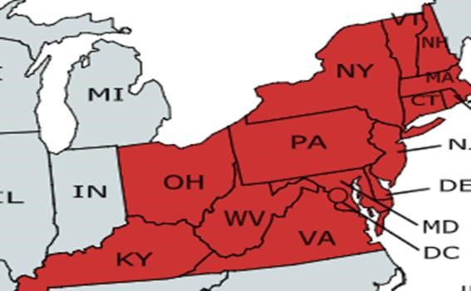

APPENDIX B – Allocation Decision Appeal Form and Outcome Review Form
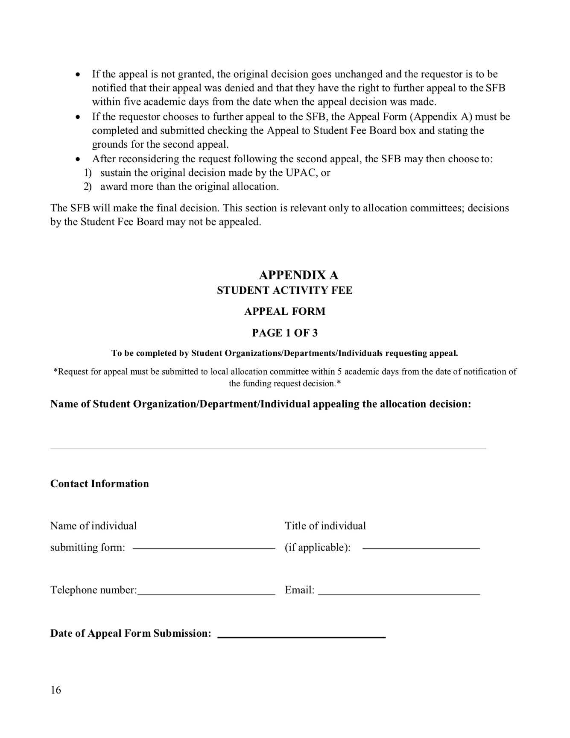
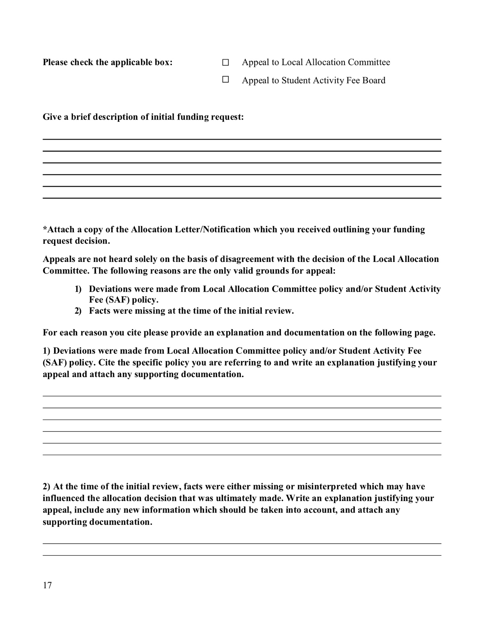
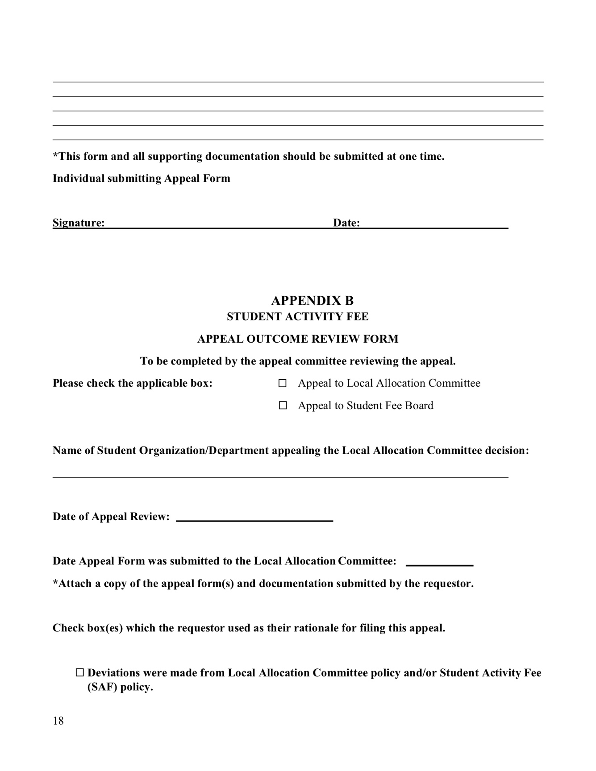
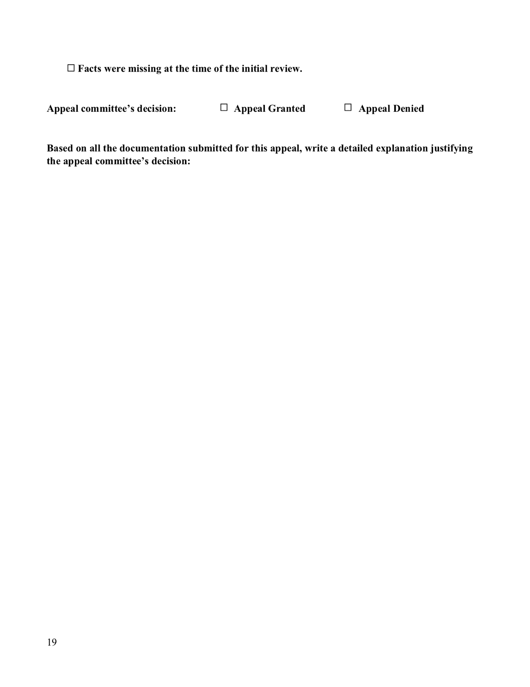

APPENDIX C – Revision History
Revision | Date  Approved | Date Effective | Description
1.0 | 08/23/2011 | 08/23/2011 | Revised Document
1.1 | 10/18/2011 | 05/07/2012 | Addition to Section 3.2.3 - The 10% Rule  Addition of Appendix J – Exception to 10% Rule Form
1.2 | 11/22/2011 | 05/07/2012 | Addition of Section 4.3 – Losing Standing Allocation Status Modification of Section 3.3.4.3 – Transportation Regulations
1.3 | 03/13/2012 | 05/07/2012 | Addition to Section 3.3.4.6 – Registration Expenses  Modification of Section 3.1 – General Information  Modification of Section 3.1.4 – Fast Track Procedure
 | 03/13/2012 | 08/27/2012 | Modification of Section 3.3.1 – Guidelines
1.4 | 04/17/2012 | 05/07/2012 | Modification of Section 3.1 – General Information
1.5 | 08/28/2012 | 08/28/2012 | Addition to Section 1.5 – Terminology Removal of Section 3.2.2 – Deadlines
Removal of Section 3.3.2 – Deadlines
Modification of Section 3.1.2 – Deadlines
Modification of Section 3.1.4 – Fast Track Procedure
Modification of Section 3.2.3 – Honoraria
Modification of Section 3.3.3.2 – Information to be submitted with request form
Modification of Section 3.3.3.5 – Lodging Expenses
1.6 | 09/11/2012 | 08/28/2012 | Addition of Section 2.5 – Additional Funding Limitations Addition of Section 2.6 – Students Ineligible for Funding
 | 09/11/2012 | 05/06/2013 | Modification of Section 3.3.1 – Guidelines
1.7 | 04/09/2013 | 05/06/2013 | Modification of Section 1.4 – Minutes  Modification of Section 3.1.2 – Deadlines
 | 04/09/2013 | 08/26/2013 | Modification of Section 3.3.3.1 – Academic Year Funding Caps
 | 04/16/2013 | 05/06/2013 | Modification of Section 1.3.3 – Policy Review
1.8 | 11/12/2013 | 11/12/2013 | Addition to Section 3.4 – Equipment
1.9 | 04/22/2014 | 05/12/2014 | Modification of Section 3.3.3.1 - Academic Year Funding Caps  Modification of Section 3.5 –Media  Removal of Section 3.6 – Broadcast Media
 | 04/22/2014 | 08/25/2014 | Modification of Section 3.3.1 – Guidelines  Modification of Section 3.3.3.2 – Information to be submitted with request form  Modification of Section 3.3.3.3 - Transportation Regulations  Modification of Section 3.3.3.5 - Lodging Expenses
1.10 | 05/06/2015 | 08/24/2015 | Modification of Section 1.5 Terminology  Modification of Section 3.2.4 International Honoraria  Modification of Section 3.3.2 Travel Experience Categories  Modification of Section 3.3.3.3 Transportation Regulations  Modification of Section 3.3.3.5 Lodging Expenses
1.11 | 01/11/2016 | 01/11/2016 | Modification of Section 1.5 Terminology  Modification of Section 3.3.1 Travel Guidelines
1.12 | 04/19/16 | 08/22/16 | Addition to Section 1.5 Terminology  Modification of Section 3.2.6  Clothing/Costumes/Apparel/Set Design/ Props  Modification of Section 3.3.2 Travel Experience Categories  Addition to Section 3.3.1 Guidelines  Removed What’s Going On Events form  Removed What’s Going On Weekly Meeting List form  Updated Appendix H to reflect Service Trip Areas
1.13 | 4/19/17 | 8/21/17 | Addition to Section 1.3.3 Policy Review  Addition to Section 1.3.1 General Allocation Review  Modification of Section 1.5 Terminology  Addition to Section 1.5 Terminology  Additions to Section 2.5 Additional Funding Limitations  Addition to Section 3.2.3 Honoraria  Removed 10% Exemption from section 3.2.2  Modification to Section 3.2.9 Publicity  Modification to Section 3.5 Media Expenses  Addition to Section 3.3.3.10 Regulations Regarding Airfare & Air Travel  Modification to Section 3.3.3.3 Transportation Regulations  Modification to Section 2.3 Limitations on SIF Fund Use  Modification to Section 1.1 Mission Statement  Modification to Section 4.2 Attaining Standing Allocation Status  Modification to Section 4.3 Losing Standing Allocation Status  Modification to Section 4.4 Budget Regulations
1.14 |  |  | Modifications to Section 3.2.3. Honoraria  Addition to Section 3.2.3. Honoraria  Modifications to Section 4.4. Budget Regulations  Modifications to Section 3.1.4. Fast Track Procedure  Modification to Section 3.4. Equipment  Addition to Section 3.3.2. Travel Experience Categories  Modification to Section 1.5. Terminology  Modification to Section 4.5. Honoraria Caps for Organizations with Standing Allocation Status  Modification to Section 3.1.2. Deadlines
1.15 | 4/16/2019 |  | Modification to Section 1.5. Terminology  Movement of Section 1.7. Revision History  Modification to Section 2.1. Repercussions of Violating Policy  Modification to Section 2.6. Students Ineligible for Funding  Modification to Section 3.1.5. Addenda  Modifications to Section 3.2.3. Honoraria  Modification to Section 3.2.6. Clothing/ Costumes/ Apparel/ Set Design/ Props  Modifications to Section 3.2.8. Program Materials/ Programs/ Receptions/ Awards/ Prizes/ Decorations, including creation of Section 3.2.8.1. Programs/ Pamphlets/ Event Guides, 3.2.8.2. Decorations, and 3.2.8.3. Receptions/ Awards/ Prizes  Modifications to Section 3.2.9. Publicity  Modifications to Section 3.3.1. Guidelines  Modifications to Section 3.3.2. Travel Experience Categories  Additions to Section 3.3.3.3. Transportation Regulations  Modification to Section 3.3.3.5. Lodging Expenses  Addition to Section 3.3.3.6. Registration Expenses  Modification to Section 3.3.3.9. Change in Number of Students Traveling  Modifications to Section 3.4. Equipment  Modifications to Section 3.5. Media  Modifications to Appendices

